[CUSTOMER DETAILS]
[DATE

Your lens care solution is changing

Dear Customer,

As a valued customer, I would like to take this opportunity to update you about a change to your lens care solution.

We have been advised of a voluntary recall by contact lens solutions manufacturer, CooperVision, of options® pure multipurpose contact lens solution. The manufacturer’s quality testing determined that the product may not offer appropriate levels of disinfection in some circumstances against high levels of a particular yeast organism. Although no complaints have been received and there have been no confirmed incidents attributed to inadequate disinfection, this action is out of an abundance of caution.

It is important you continue to clean and disinfect your soft contact lenses. Please cease use and discard your options® pure multipurpose solution once you have secured an alternative multipurpose solution. Please retain the bottle in order to obtain your reimbursement, which you can do by visiting the recall website: www.CVrecall.expertinquiry.com. This website is managed by Sedgwick, the company that are supporting CooperVision on this recall. On the website you will be given more information on what to do next and instructions on how to claim your reimbursement. You will also find contact details should you need to speak with a representative.

As your current product, options® pure has been voluntarily recalled it is currently not available to order. As an alternative, we recommend options® classic – the versatile multipurpose solution specially formulated for patients with sensitive eyes.

options® classic multipurpose solution

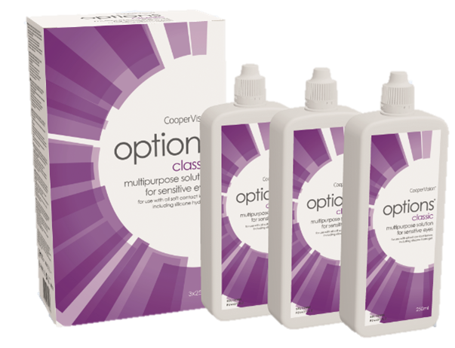 | Multipurpose solution for sensitive eyes:  Proven performance for cleaning, rinsing, disinfecting and storage of soft contact lenses  - Effective disinfection,¹ reduces bacteria by 99,9%  - Wetting properties enhance lens comfort^{2,3,4}  - Proven clinical performance with all soft lens types including silicone hydrogels  - Ease of use with all needs in one bottle
If you are happy to change your lens care solution to options® classic, you are not required to do anything. We will update your details and automatically ship your new lens care solution with your next order. You can use this solution in the same way as you have done before. You can review by reading the instructions for use leaflet available in the solution pack.

If you would like any further information, please contact us.

Yours sincerely

[NAME]
[TITLE]

