[CUSTOMER DETAILS]
[DATE

Your lens care solution is changing

Dear Customer,

As a valued customer, I would like to take this opportunity to update you about a change to your lens care solution.

Your current product, options® pure is currently not available to order.

As an alternative, we recommend options® classic – the versatile multipurpose solution specially formulated for patients with sensitive eyes.

options® classic multipurpose solution

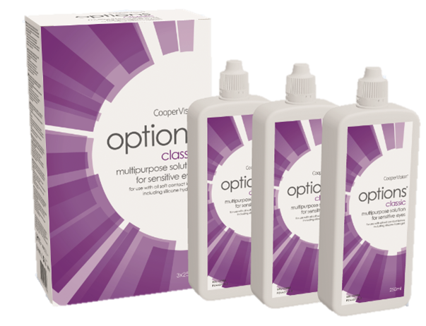 | Multipurpose solution for sensitive eyes:  Proven performance for cleaning, rinsing, disinfecting and storage of soft contact lenses  - Effective disinfection,¹ reduces bacteria by 99,9%  - Wetting properties enhance lens comfort^{2,3,4}  - Proven clinical performance with all soft lens types including silicone hydrogels  - Ease of use with all needs in one bottle
If you are happy to change your lens care solution to options® classic you are not required to do anything. We will update your details and automatically ship your new lens care solution with your next order. You can use this solution in the same way as you have done before. You can review by reading the instructions for use leaflet available in the solution pack.

If you would like any further information, please contact us.

Yours sincerely

[NAME]
[TITLE]

