NOTIFICATION – CUSTOMER TO PATIENT
[FOR CUSTOMERS TO PLACE ON THEIR WEBSITE / COMMUNICATE DIRECTLY TO INFORM PATIENTS OF THE ACTION AND WHAT TO DO]

PRODUCT RECALL
All in One Light® (60ml) Multipurpose Contact Lens Care Solution
60ml Bottle Configuration
Lot 162046
We have been advised of a limited voluntary recall by the manufacturer, CooperVision, of a single lot of All in One Light® multipurpose contact lens solution (60ml bottle).

The affected lot number is 162046.  Note only 60ml bottles are affected and no other bottle sizes are included in this action.  Lot numbers are printed on the back of each bottle, towards the bottom. | 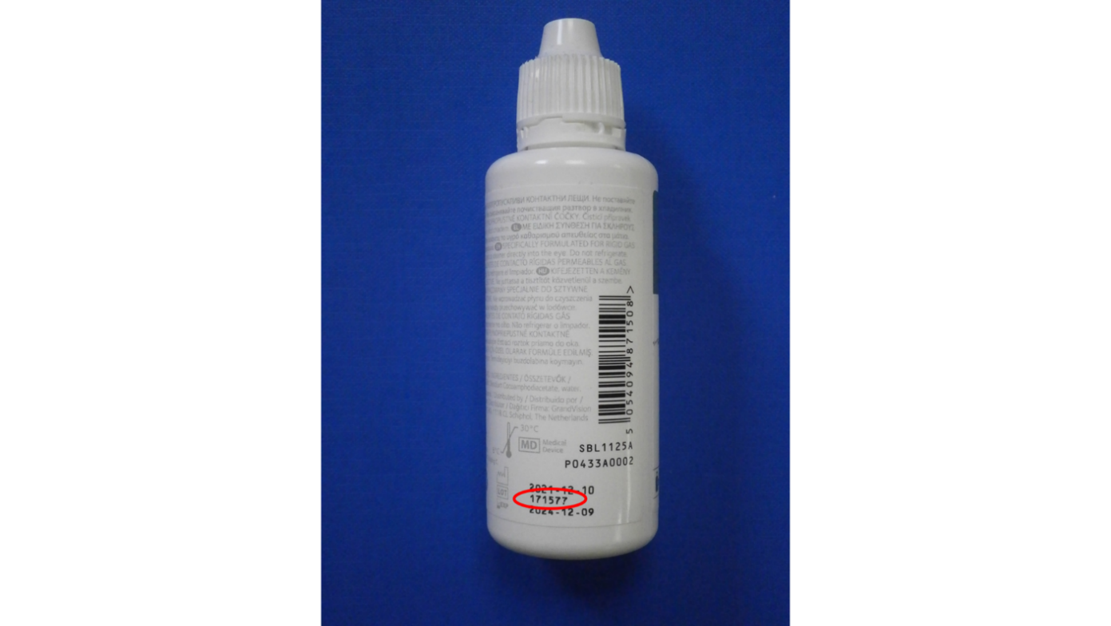

The manufacturer has advised the following:
Routine quality testing is performed on retained product samples. For the affected lot, sterility test results conducted on some of the retained samples failed to meet criteria at the 12-month time interval. Although no complaints have been received for the affected lot and there have been no adverse events, this limited voluntary recall is being taken out of an abundance of caution.
If you possess product from the affected lot of All in One Light® 60ml multipurpose contact lens solution, please cease use and retain the bottle. The manufacturer will soon provide a recall website where impacted consumers can receive further information. This website will be found at: www.infoCV.expertinquiry.com and is anticipated to be live on 12th August 2022.

